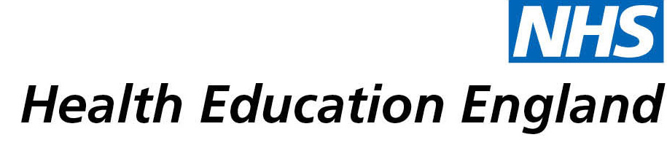

# Library and Knowledge Services case study

# *Gloucestershire Hospitals NHS Foundation Trust Library and Knowledge Services: training session leads to successful online transition of a brain injury fatigue management group*

Date 27/04/21

## Reason for enquiry

Nicky Jago, occupational therapist, started a Masters Degree in September 2020, and asked the Library and Knowledge Services for training on database searching and finding evidence for an assignment.

## What the knowledge and library specialist did

*Camila Garces-Bovett, librarian and training lead, delivered online training to Nicky on finding evidence and using the medical and healthcare databases (such as AMED and EMBASE) via NICE Healthcare Databases Advanced Search. The session covered PICO, evidence resources, Boolean search terms, building a search strategy, and a step-by-step guided search. After the session, when contacted by Nicky, Camila provided further specific advice on Nicky’s search strategy and keyword combinations.*

# Impact of input from the library and knowledge service

*The search training* *“increased [Nicky’s] confidence to search databases and increased [her] skills regarding finding evidence”.*

*This allowed her to conduct a literature search for her Masters assignment which “focussed on an area of change in practice” (the in-person fatigue management group for brain injury patients run by Occupational Therapy at GHNHSFT) – which she subsequently passed with distinction.*

*Her confidence and new skills in literature searching also helped patient care: the Trust’s in-person fatigue management group for brain injury patients had had to be suspended due to COVID-19. But Nicky was able to find evidence on “whether a virtual group could be provided to maintain therapeutic contact for patients and continue to support with fatigue management strategies”. Thanks to the training she received, she was able to prove that a virtual group would support fatigue management strategies, so the group is now run virtually and “patient feedback is positive”.*

## Immediate Impact

* *Help with decision-making: as a result of the evidence found while doing her search for her assignment, Nicky was able to make the decision to continue running the group, albeit online.*
* *Patient care and patient experience: the fatigue management group has continued to run online as a result of the evidence that Nicky found with her new searching skills. “[P]atient experience of the group has been positive. We have not collated all of the patient satisfaction data yet but without this virtual group these patients would not have had support to manage their fatigue”*

## Probable future Impact

* *Improve / develop services for patients: as a result of running the group online, Nicky has completed a research proposal “to investigate the effectiveness of the group in reducing the impact of fatigue for patients with mild to moderate brain injury. We hope to offer patients a choice in their therapy in the future (e.g., face to face or virtual group)”*
* *Share information with, or advise, other staff and colleagues: “An abstract detailing this pilot group has been submitted and accepted by the Royal College of Occupational Therapists and myself and my colleague will be presenting [our findings] at their virtual conference in July.”*
* *“Greater choice in group provision for patients. Virtual groups are potentially positive for lots of reasons e.g., reduced travel time, cost of travel and parking at the hospital, able to access group from own home, increasing comfort and reducing anxiety.”*

## Submission by:

*Nicky Jago, Occupational Therapist, Brain Injury Team.*

## For further information on how you can get similar support contact your local NHS library and knowledge service.